**17/2/2024**

**Objectives**

1. Thoroughly explaining the innovation project and highlighting the steps. Provide an example of Izzy from FLL Challenge overview and steps from FLL Challenge Overview.
2. Introducing the FLL Robot game and displaying a video of all missions.
3. Highlight 8 principles of the robot game from the rule book.
4. Introduce the FLL challenge set and assembling possible challenges.
5. Navigation and possibly solving tasks on the prepared mat.
6. Providing the FLL robot game rule book and building instructions to all school

**GSNDA Rwaza**

**Training overview**

1. Started the session with an ice break of saying countries based on the letters of the alphabets.
2. Had a recap of the previous session by going over the theme, core values and the components of the spike prime kit.
3. Taught the main steps for the innovation project including identification of challenge to the hobby they want to share, research and generation of solutions, designing the solution, development, and iteration of solution and finally presentation of the solution. Gave the example of Izzy and others.
4. Identified possible hobbies they have. They include:
   1. **Playing Basketball-** problem identified was that disabled people are unable to play. Here they proposed a prosthetic arm to aid those who don’t have arms to play basketball.
   2. **Preparing make-up –** here they proposed a robot that can make makeup. This was based off a hobby, and they are still working on the problem statement.
5. Watched a video of the FLL masterpiece challenges and discussed the 8 principles of robot game from the rule book.
6. Assembled challenges 1, 12, 14, 15 and 5 (half of it was made). They proposed ways to solve challenges like 12 resulting in the development of a gear for the challenge.
7. Provided the rulebook and the building instruction for all the challenges.

**Challenges**

1. The students have tests next week which limits their time to assemble challenges as well as conduct research for innovation project. They stated they might provide more hours on Thursday to prepare.
2. The students were constantly distracted by the match being held that day requiring more effort to keep them engaged.
3. Transport is tedious since I was late for my next session at GS cyabagarura due to lack of bikes or cars that go from GS Rwaza to Musanze.

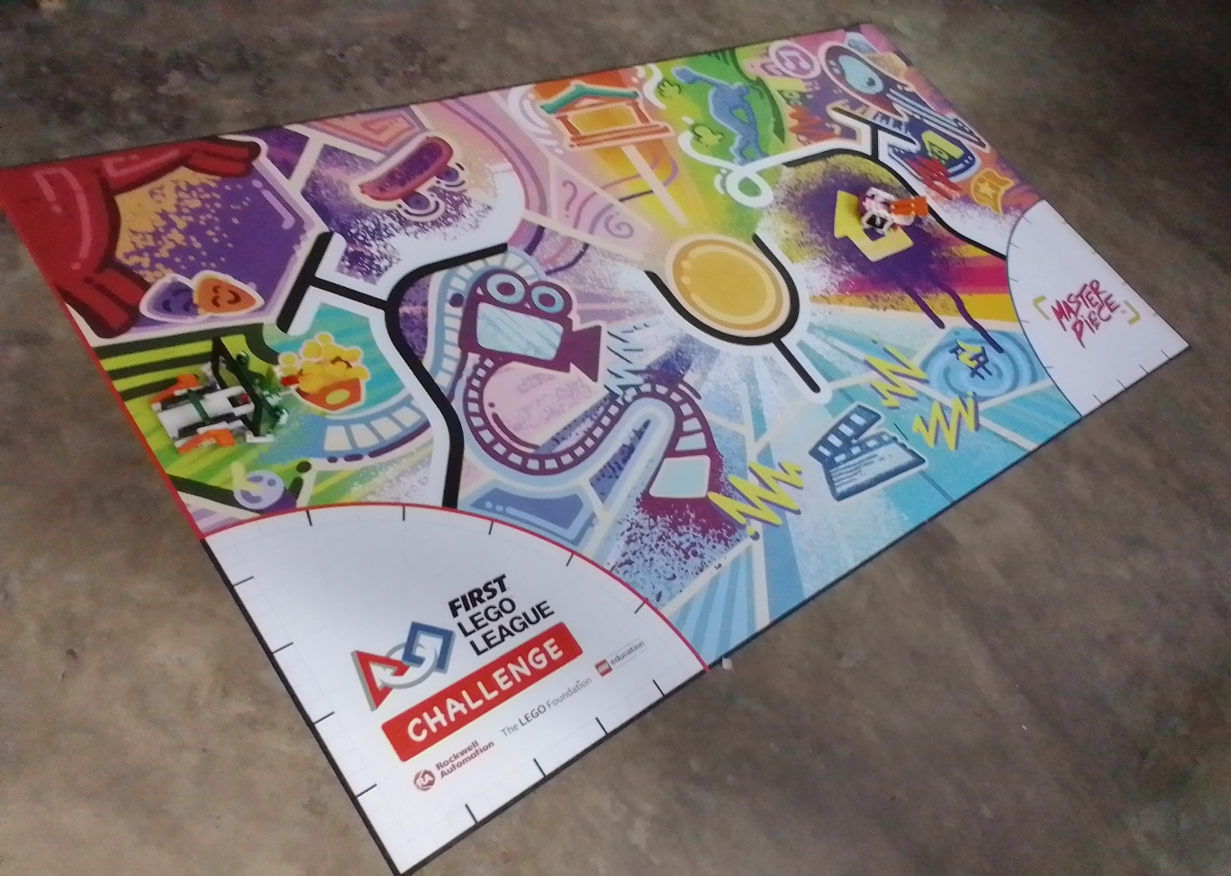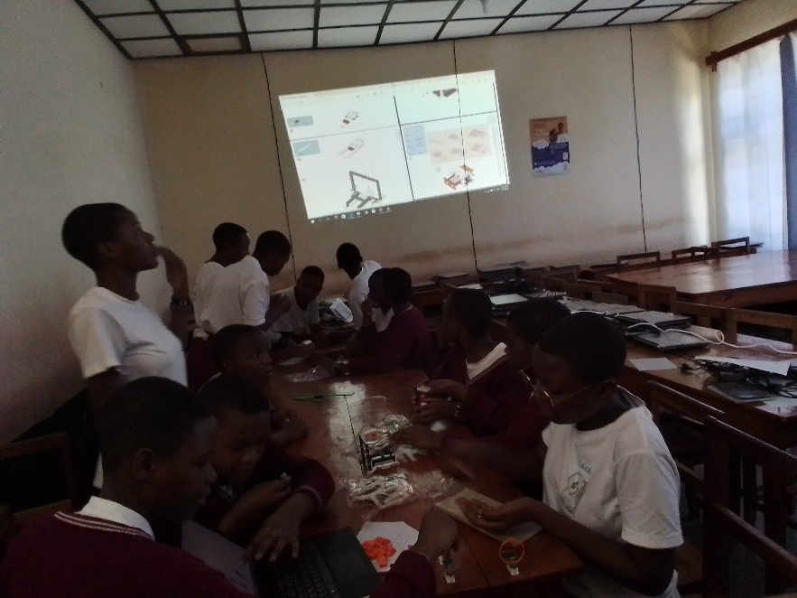Overall, the students tried to ideate on the innovation project with the assistance of their teacher and we managed to assemble 4 and a half mission upon receiving the set today. They remained with an assignment to choose the best hobby they will work on and conduct research to find solutions which they will present on the next session possibly on Thursday.

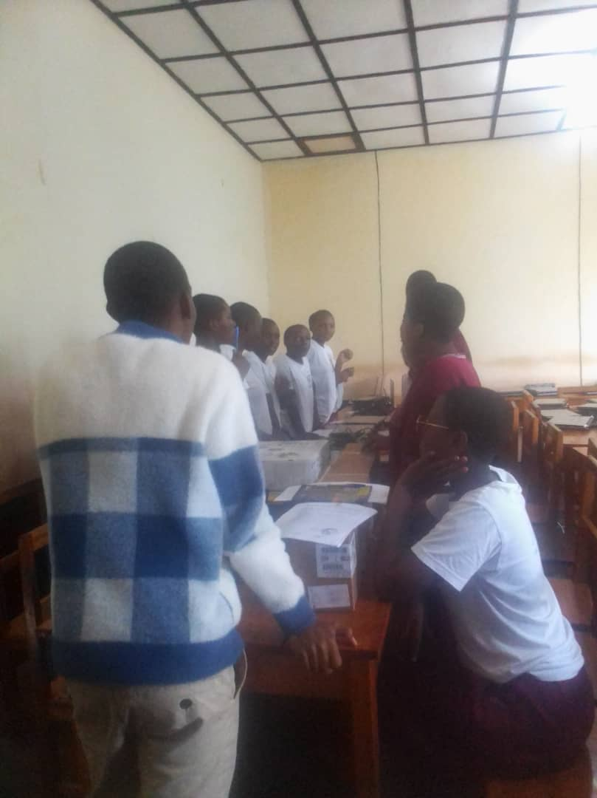

**GS Cyabagarura**

**Training overview**

1. Had a recap of the previous session by going over the theme, core values and the components of the spike prime kit.
2. Tried to identify their hobbies. They suggested:
   1. **Playing football**- Problem identified was that disabled people are unable to play. They also proposed a prosthetic leg.
   2. **Reading**- problem identified was that few people like reading.
   3. **Listening to music-** they identified a problem of different genres for different people. So, people like some kind of music while other prefer different kinds.
3. Taught the main steps for the innovation project including identification of challenge to the hobby they want to share, research and generation of solutions, designing the solution, development, and iteration of solution and finally presentation of the solution. Gave the example of Izzy and others.
4. Watched a video of the FLL masterpiece challenges and discussed the rules through the video.
5. Assembled challenges 1, 12, 14 and 15. Successfully solved half of challenge 14 and navigated back to the opposite launch area to try challenge 1.
6. Provided rulebook and building instructions for each challenge.

**Challenges**

1. Delayed to the session since I couldn’t find transport from GS Rwaza.
2. The students also have tests next week which limits the amount of research and time for assembly. They accepted to work on assembly at 1 after lunch though.

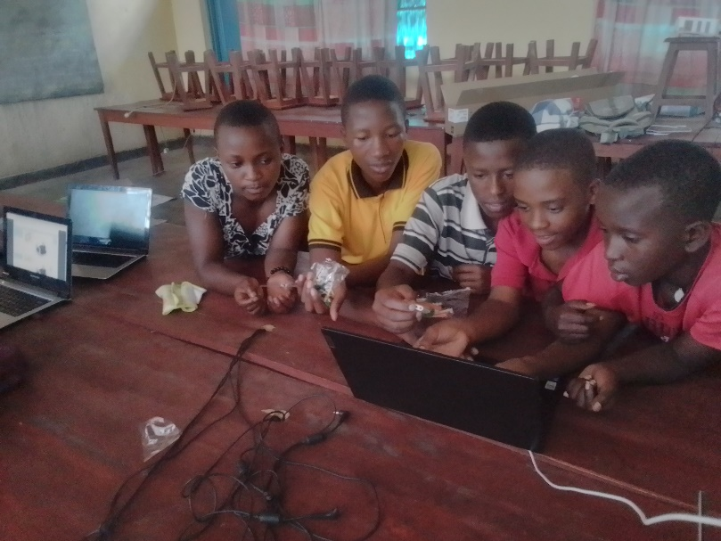Overall, the students looked really excited to get started with the challenges and tried to solve them with their own codes. They were resilient and continuously tried until it worked.

